

Name: ___________________________________________ Period: _____

As we learned in our last activity, Chi-square is a mathematical way to tell if a probability-based experimental result is valid or not. For example, tossing a coin and getting heads is 50%. If the coin were tossed numerous times, it should (according to the law of probability) be very close to 50%. However, it is not likely to be exact. How can we tell if our results were valid or not? We will use chi-square.
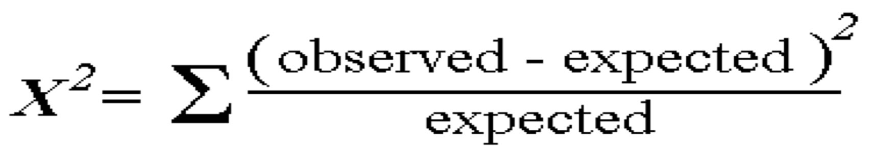

COIN TOSS: Toss a coin 30 times and record your results below.

Side | Observed | Expected | Difference | Diff²/Exp
Heads |  | 15
Tails |  | 15

Degrees of Freedom = _________ X² = _________

Accept or Reject Theory = ______________________

By pooling together our class data, our results should be better…
Side | Observed | Expected | Difference | Diff²/Exp
Heads
Tails

Degrees of Freedom = _________ X² = _________

Accept or Reject Theory = ______________________

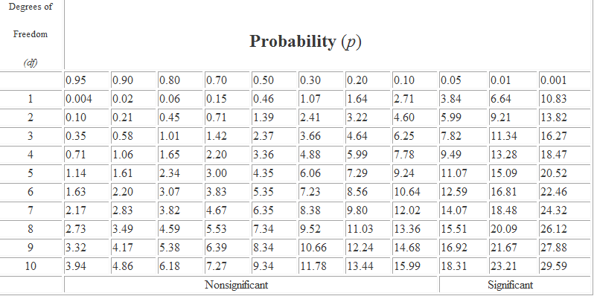

CHI-SQUARE and M&M’s: According to the Mars Company, M&M’s are produced in specific proportions. The color ratios are in the chart below. Let’s see if the percentages indicated by the Mars Company can be deemed accurate based on a small sample of candy.

Color | Number Observed | Observed % | Expected % | Difference | Diff²/Exp
Blue |  |  | 24
Brown |  |  | 13
Green |  |  | 16
Orange |  |  | 20
Yellow |  |  | 13
Red |  |  | 14
Total

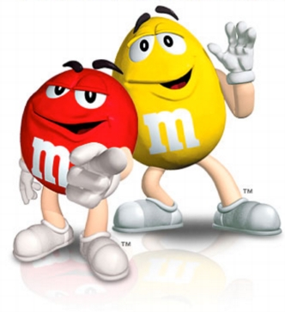
Degrees of Freedom = _________ X² = _________

Accept or Reject Theory = ______________________

Again, let’s pool our class results…
Color | Number Observed | Observed % | Expected % | Difference | Diff²/Exp
Blue |  |  | 24
Brown |  |  | 13
Green |  |  | 16
Orange |  |  | 20
Yellow |  |  | 13
Red |  |  | 14
Total

Degrees of Freedom = _________ X² = _________

Accept or Reject Theory = ______________________

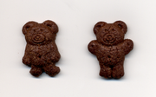
CHI-SQUARE and Teddy Grahams: Teddy Grahams come with their hands up or their hands down (you’ve never noticed this? Really?). Obtain some Teddy Grahams and count how many have their hands up or their hands down. Check the hypothesis that there are equal amounts of both types of Teddy Grahams in a sample.

Hands | Number Observed | Observed % | Expected % | Difference | Diff²/Exp
Up |  |  | 50
Down |  |  | 50
Total

Degrees of Freedom = _________ X² = _________

Accept or Reject Theory = ______________________

Again, let’s pool our class results…
Hands | Number Observed | Observed % | Expected % | Difference | Diff²/Exp
Up |  |  | 50
Down |  |  | 50
Total
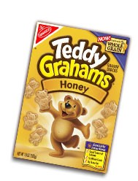
Degrees of Freedom = _________ X² = _________

Accept or Reject Theory = ______________________

Conclusion Questions:

- Which chi-square test was the MOST reliable?

- Which chi-square test was the LEAST reliable?

- What would be another good food to test for chi-square and what trait would we analyze? Your answer cannot be an M&M type food (no Reese’s Pieces, Skittles, etc.).

